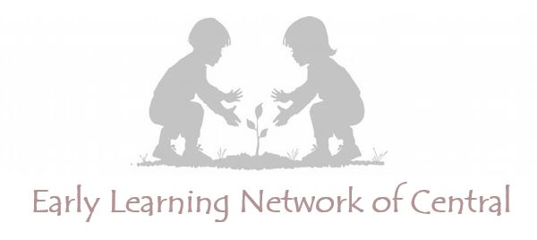

Central Community Enrollment Application

- family information

child Information
Child’s Full Name: _______________________________________________________________

Date of Birth: _______________ Age: _______ Gender: ___________ Race: ____________

Is the child potty-trained? Yes or No

Does child receive Special Education Services? (IEP): Yes or No

Does child receive Speech Services? (IEP): Yes or No

Does child receive Early Intervention Services? (IFSP): Yes or No

Does child have a suspected disability? Yes or No

If Yes, what is the suspected disability? ________________________________________________

In what kind of setting does your child currently receive care?
□ no previous child care □ in-home care □ care at a center/facility
(please specifiy: ________________________)

Guardian Contact Information
Guardian Name: ____________________________________________________

Relationship to Child: __________ Number in Household: _____ Primary Language: _________

Phone: ____________________ E-mail: _________________________________

Household eligibility Information
Does anyone in your household currently receive SNAP or CCAP assistance? Yes or No

To apply online, go to elncentral.com and click on “Enroll.”
Child’s Full Name: ______________________________________________________________

- family preferences

Rank Program Preference

Ranking a program 1st or 2nd DOES NOT guarantee enrollment. Enrollment can be limited by factors including availability of seats and preferences given for siblings of other children in care.
Please rank the programs below in order of preference. Put a “1” for your first choice, “2” for your second choice, and so on. Only rank programs for which you are eligible.

Ranking Program Type

_______ Abundant Blessings Early Learning Center Child Care Center

_______ Bellingrath Hills Elementary School Public School

_______ Central Early Learning Center Child Care Center

_______ Imagination Station Childcare and Learning Center Child Care Center

_______ Kids Palace Child Care Center

_______ Lil Wildcats Child Care Child Care Center

Sibling Information

If child has any siblings currently attending any program above, please list below:

Sibling Name Center/School Age

_______________________ ___________________________________ _______

_______________________ ___________________________________ _______

_______________________ ___________________________________ _______

By signing this, I give permission for the information provided in this application to be shared with the programs in the Early Learning Network of Central as I have ranked them above, in order to help me find any available seats at the sites of my choosing. I understand that my submission of this form does not guarantee me a seat in any particular program.
Printed Name of Guardian: ____________________________________
Guardian Signature: __________________________________________ Date: ___________________

